Jira Software Your work vFilters v Dashboards v People v Apps v

Projects / Customer Care Registry / CCR board Reports

# Burndown Chart

CCR sprint 4 Issue Count How to read this chart

|  |
| --- |
| Q Search |

|  |
| --- |
| Guideline  Remaining Values  Non-Working Days  Show Non-Working Days |
|

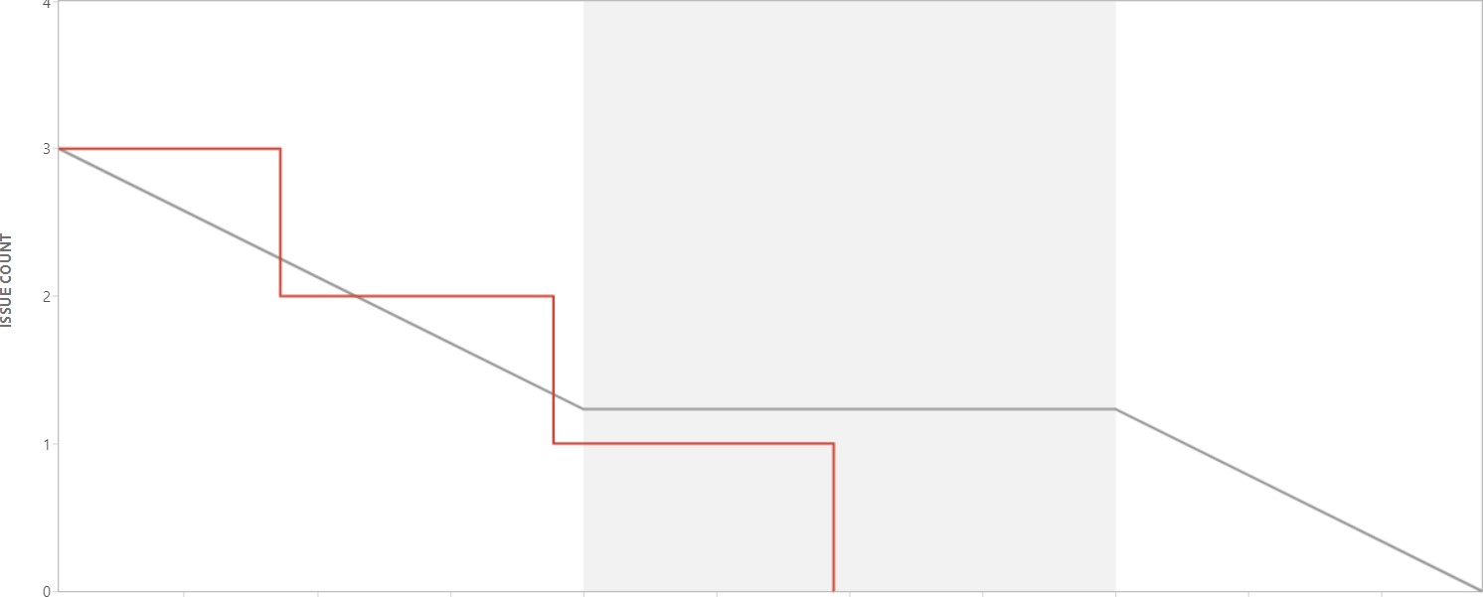 •



Projects

Nov 10 12:00 Nov 11 0:00 Nov 11 12:00 Nov 12 0:00 Nov 12 12:00 Nov 13 0:00 Nov 13 12:00 Nov 14 0:00 Nov 14 12:00 Nov 15 0:00

TIME

Issue Count

